**BUDT703 Group_0501_02**

**ReadMe**

**Brand Name- HUNGRY TERPS!**

**Data Source:**

<https://www.yelp.com/search?find_desc=&find_loc=College+Park%2C+MD+20740&ns=1>

Yelp has been chosen to create the database for this project because the reviews on Yelp were honest and credible. Also, it made it easier to transfer information from this website and use it in our project.

**Intended users:**

The users of this database will primarily be but not be limited to students. Anyone who wants to get reviews of a particular restaurant in College Park can use the database.

**Project Testing Methodology:**

**Executing DROP Statements:**

These queries are in the file- Project_0501_02_CREATE_AND_DROP.sql

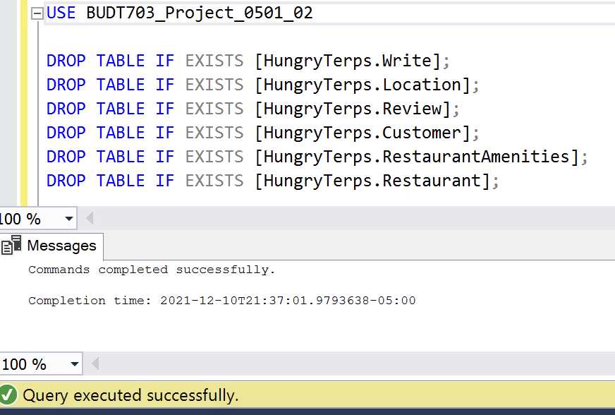

**Executing CREATE Statements**

These queries are in the file- Project_0501_02_CREATE_AND_DROP.sql

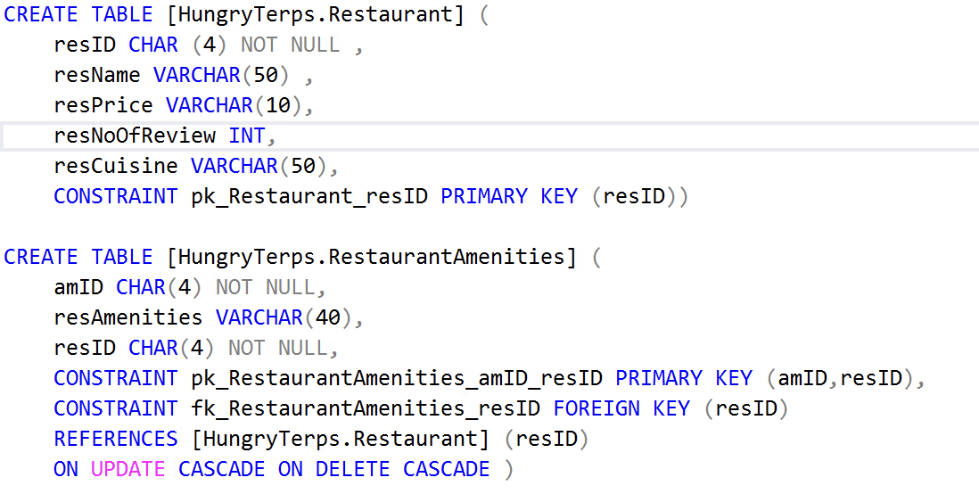

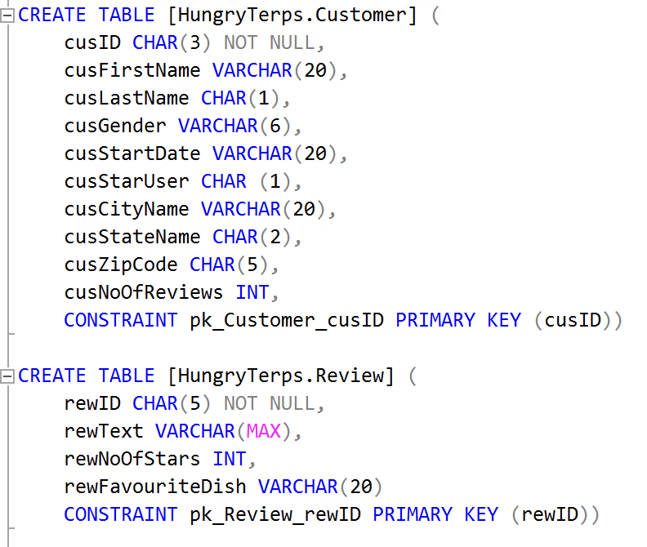

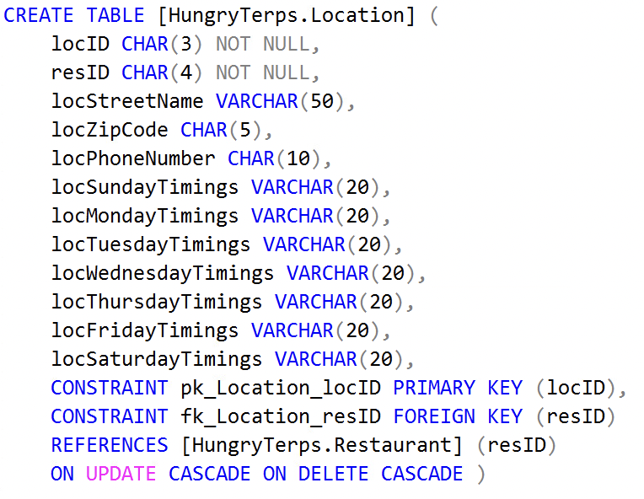

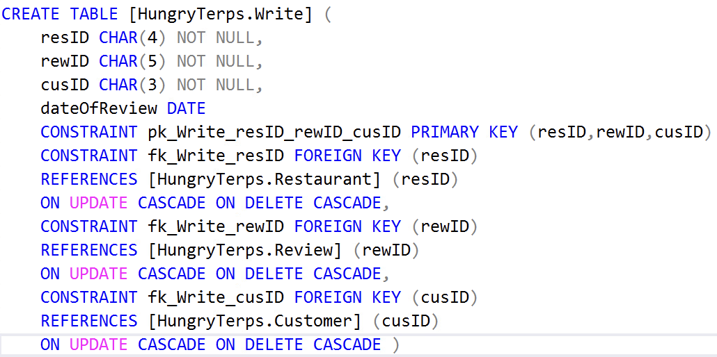

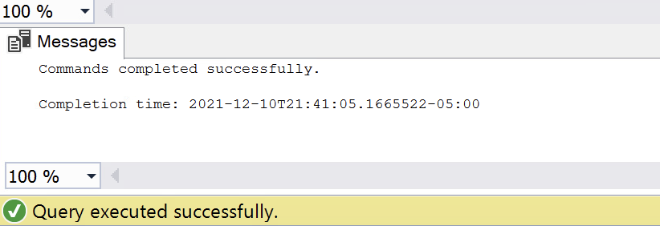

**Executing INSERT Statements**

These queries are in the file- Project_0501_02_INSERT.sql

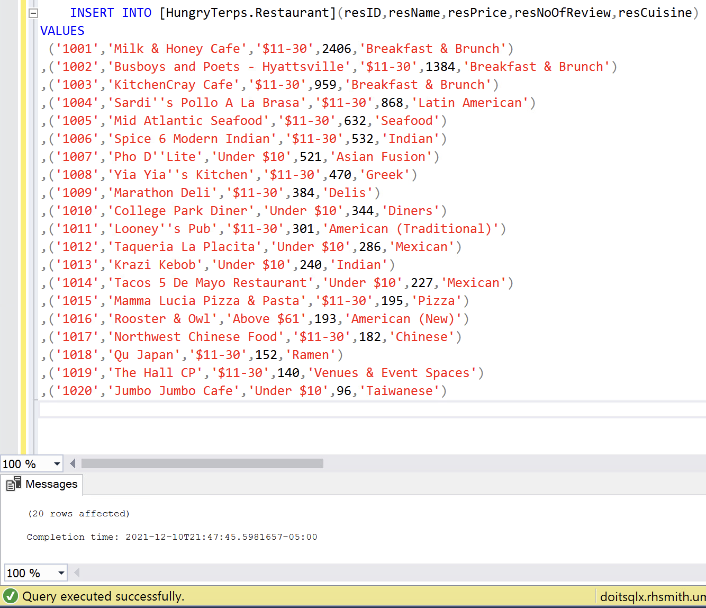

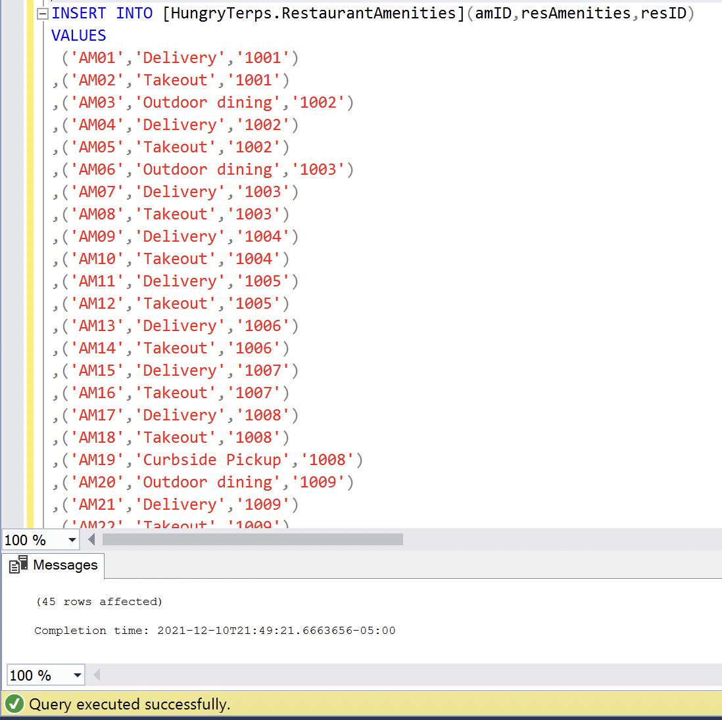

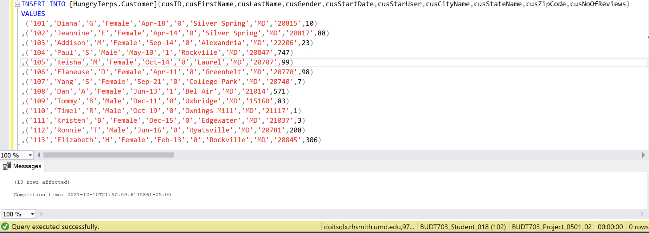

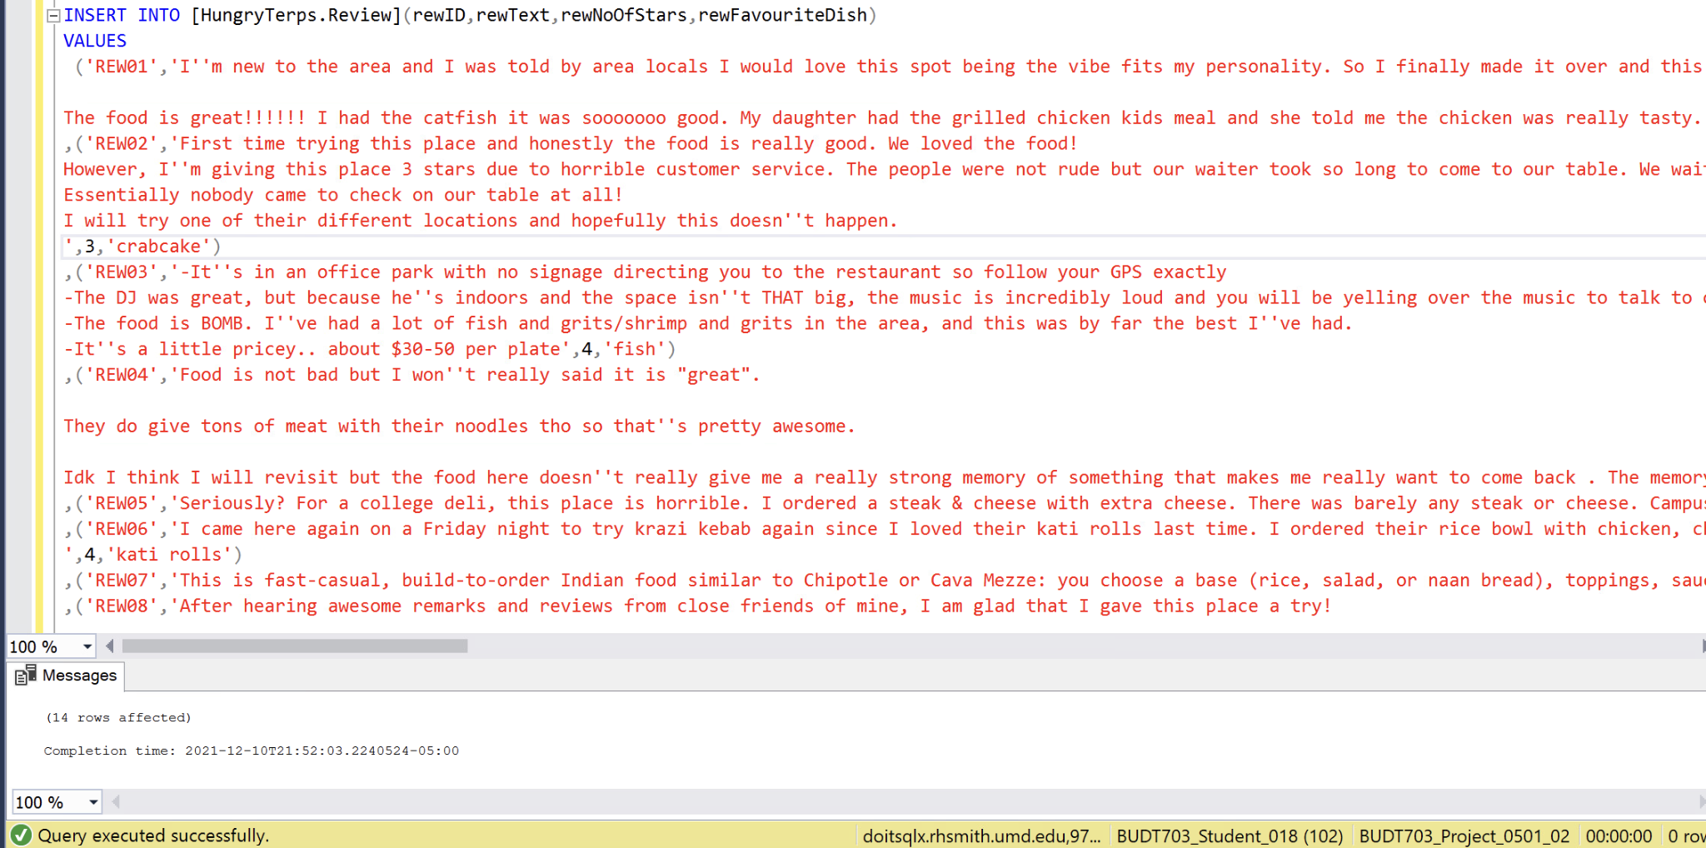

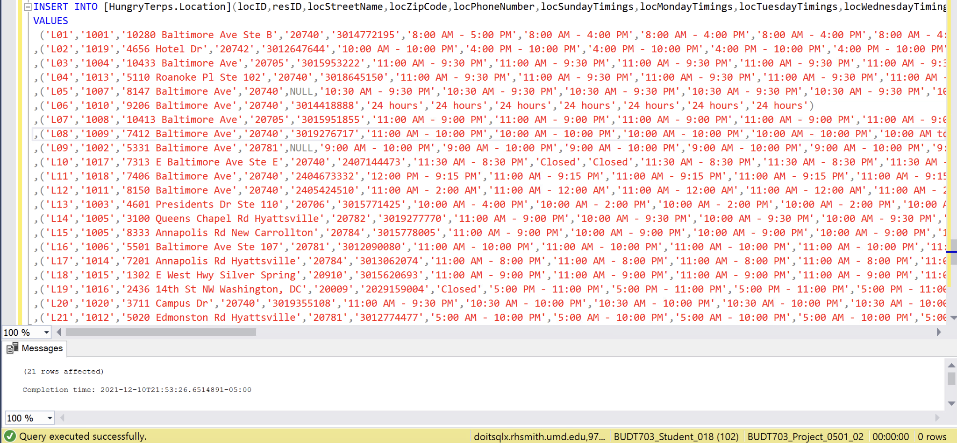

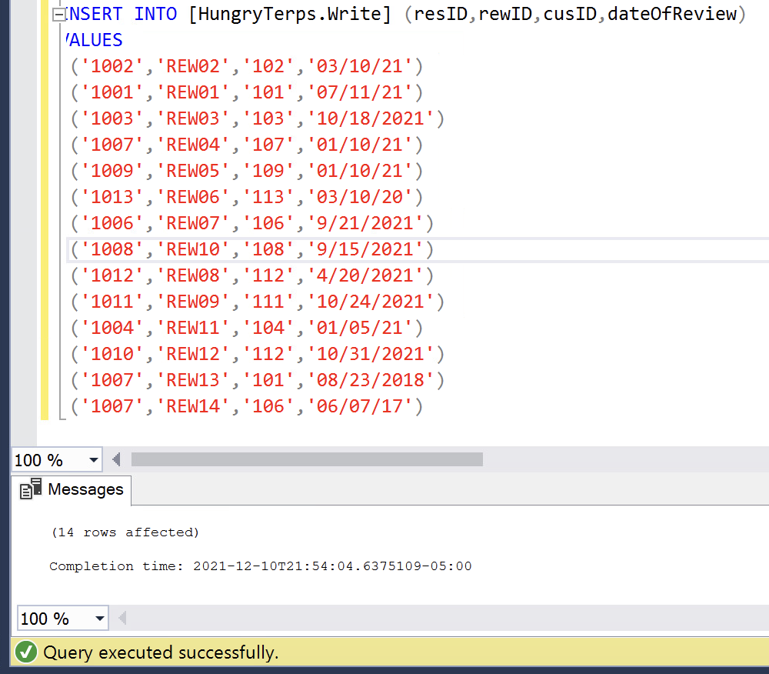

**Executing DROP VIEW statement:**

These queries are in the file- Project_0501_02_VIEWS.sql

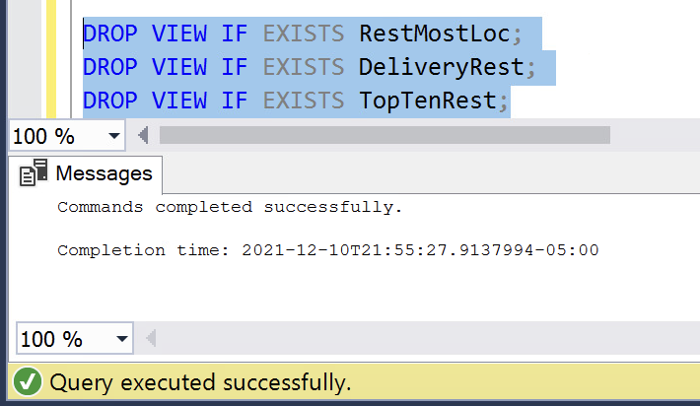

**Executing CREATE VIEW statement**

These queries are in the file- Project_0501_02_VIEWS.sql

List of restaurants that offer delivery services

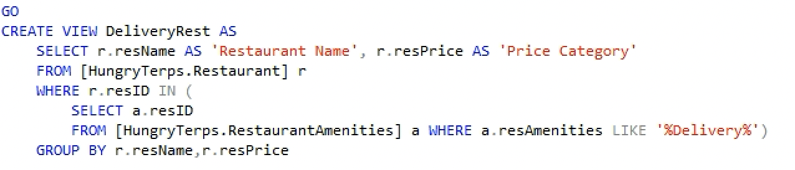

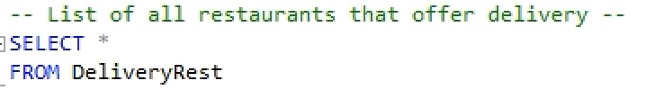

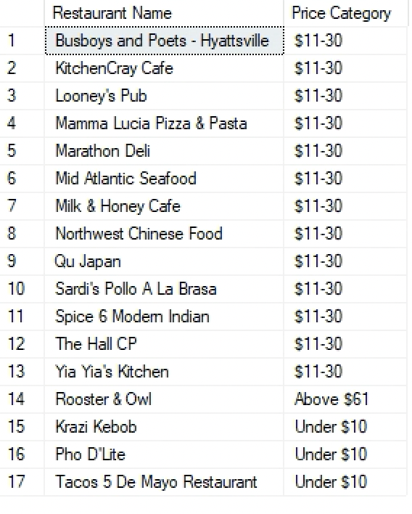

List of top ten restaurants based on count of reviews

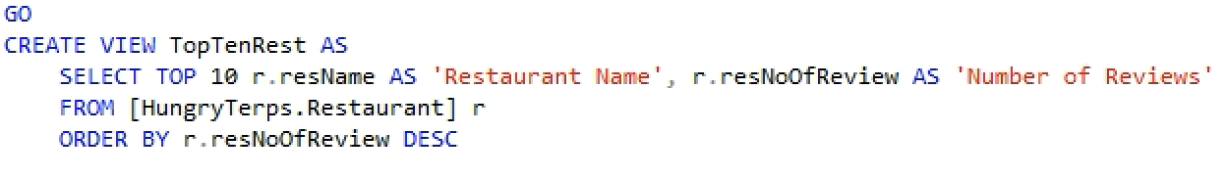

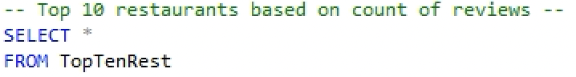

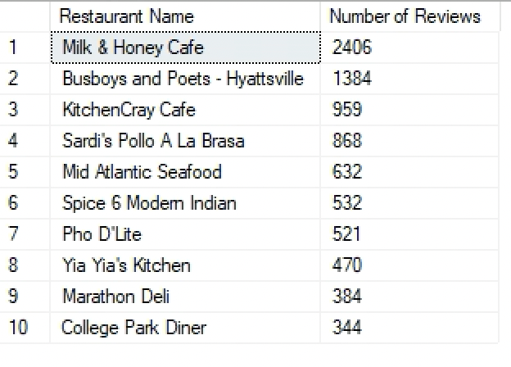

List of restaurants that are present in multiple restaurants

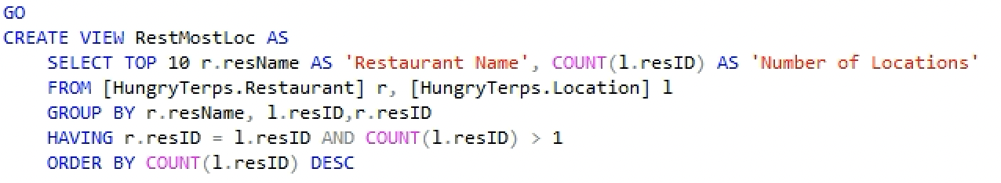

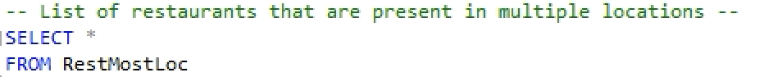

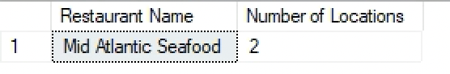

**Executing SELECT statements:**

These queries are in the file- Project_0501_02_IMPLEMENTATION.sql

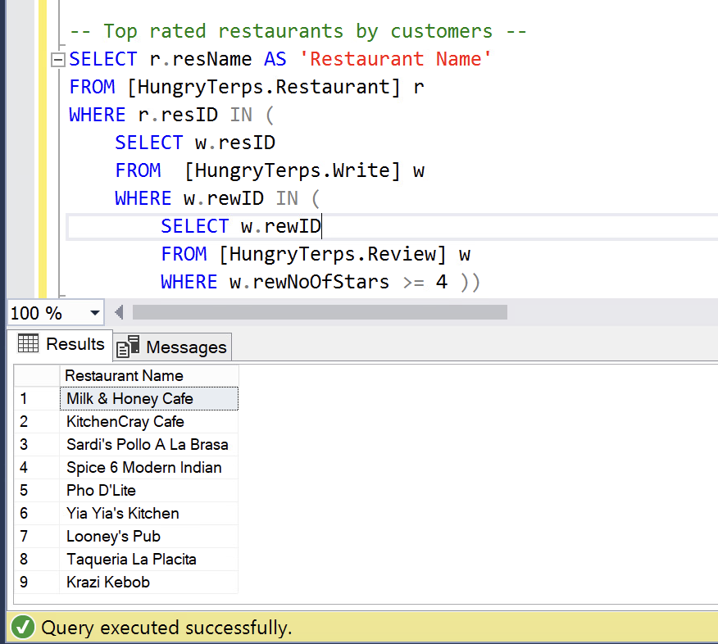

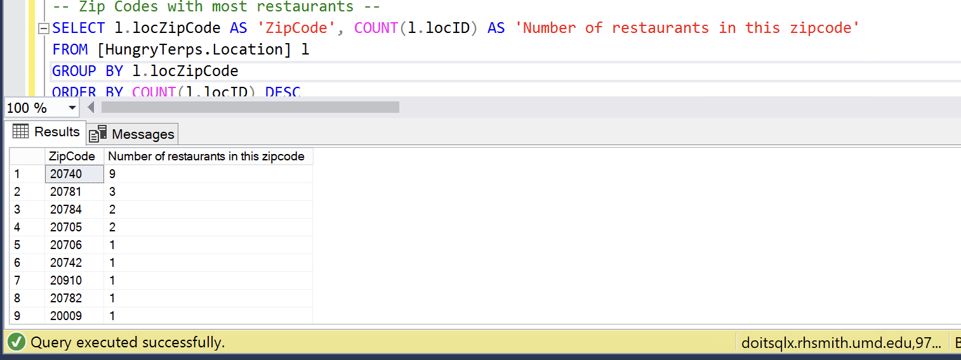

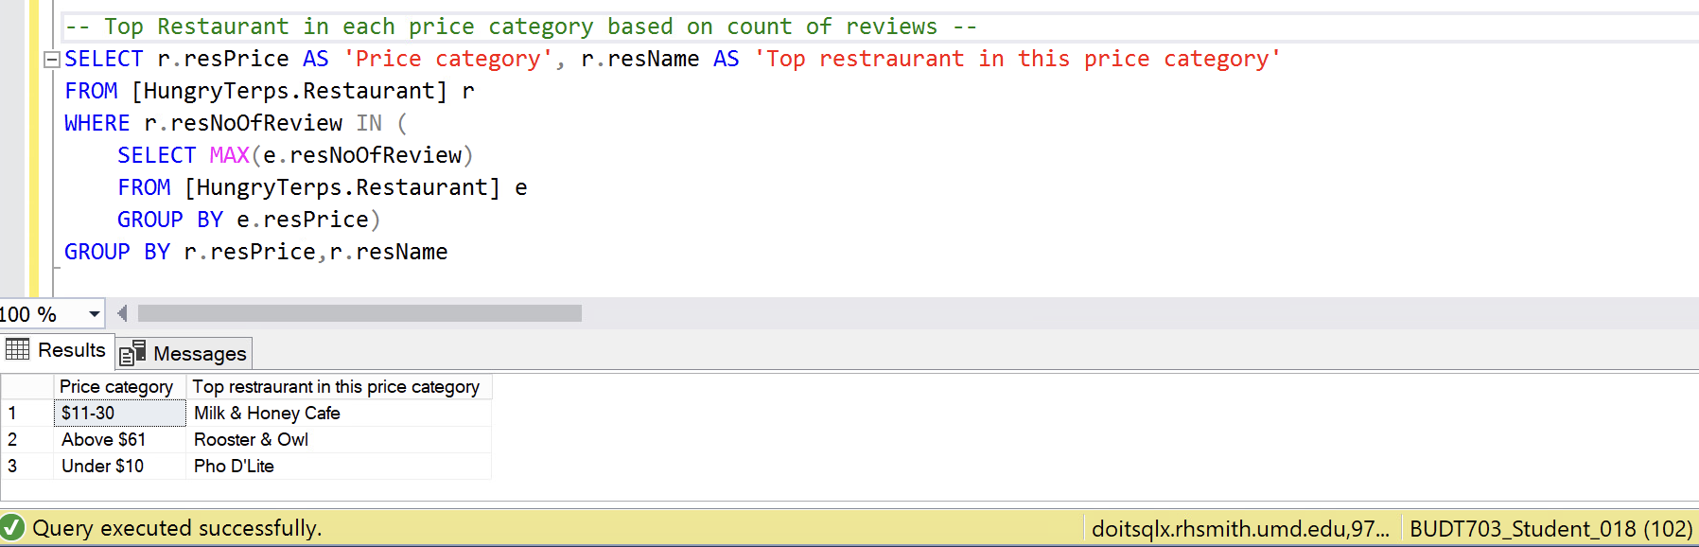

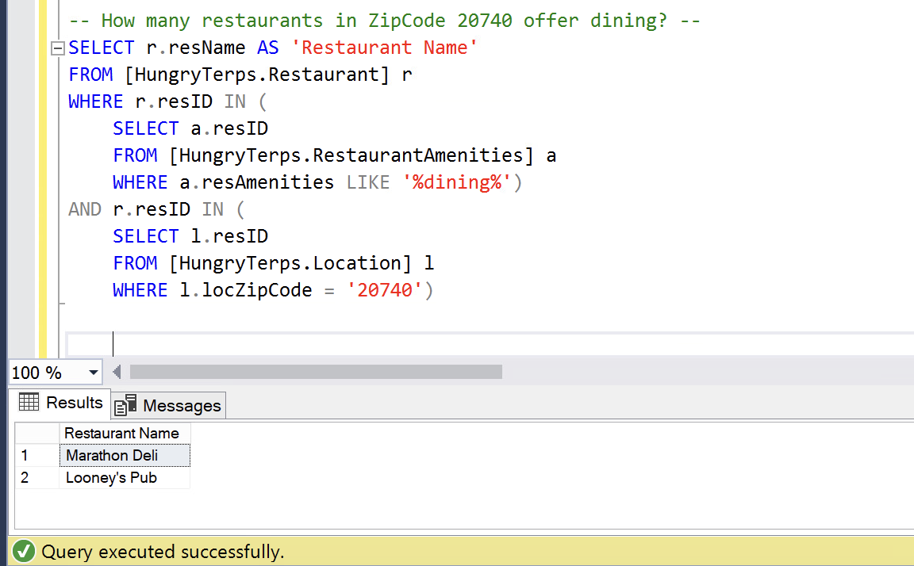

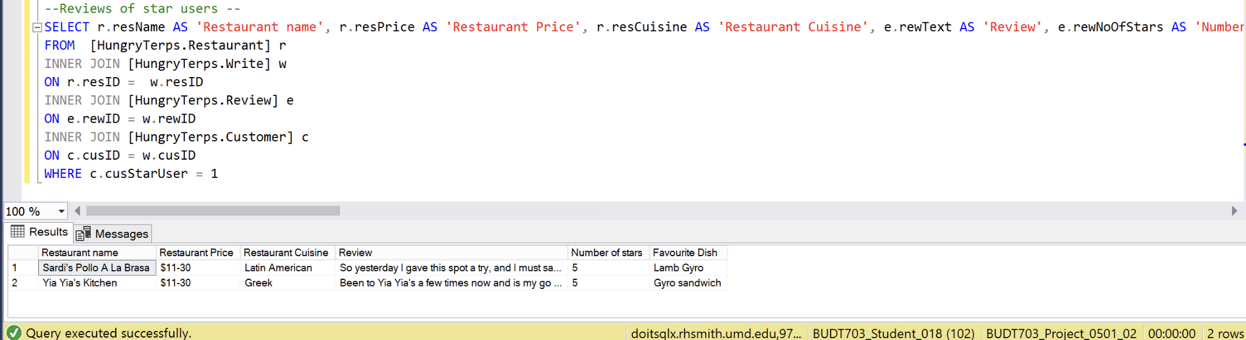

**REFERENCES:**

<https://www.w3schools.com/sql/sql_top.asp> - **For TOP**

<https://docs.microsoft.com/en-us/sql/t-sql/data-types/char-and-varchar-transact-sql?view=sql-server-ver15> **- For VARCHAR (MAX)**

<https://www.lucidchart.com/pages/er-diagrams> **- To improve ER Diagram**